* The regular expression for the digit:
  + [0-9].
* The NFA:

* The DFA:

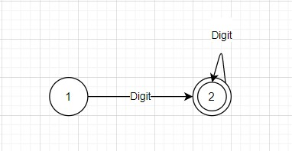

* The transition table:

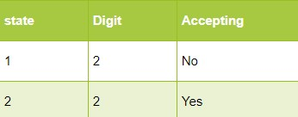

**###################################**

* The regular expression for the reserved words:
* (Pattern|DerivedFrom|TrueFor|Else|Ity|Sity|Cwq|CwqSequence|Ifity|Sifity|Valueless|Logical|BreakFromThis|Whatever|Respondwith|Srap|Scan|Conditionof|Require).
* The NFA:

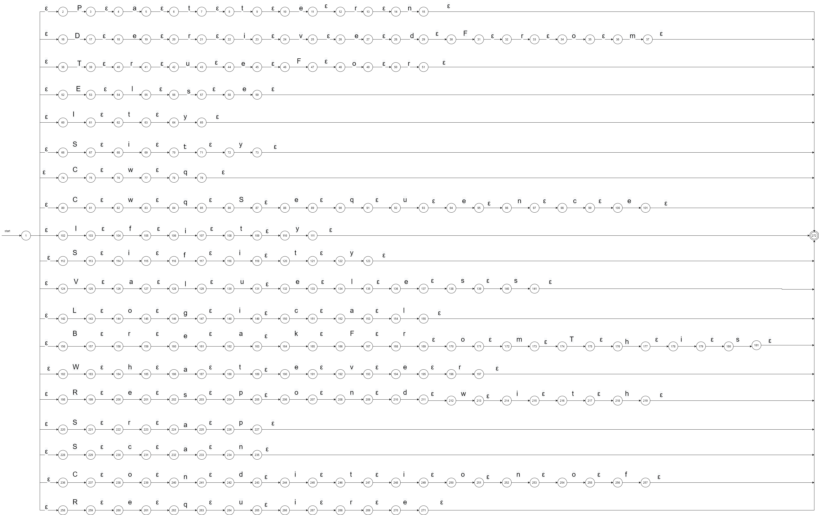

* The DFA:

* The transition table:



**###################################**

* The regular expression for the symbols:
  + (@|$|+|-|*| /|&&| || | ~| ==| <| >| !=| <=| >=| =| ->| {| }| [| ]| '| "| /-| -/ |--| #| ^).
* The NFA:

* The DFA:

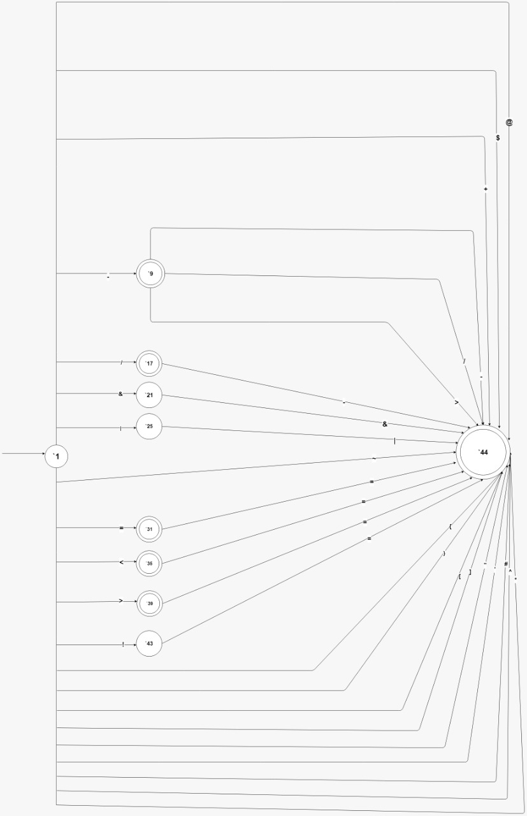

* The transition table:

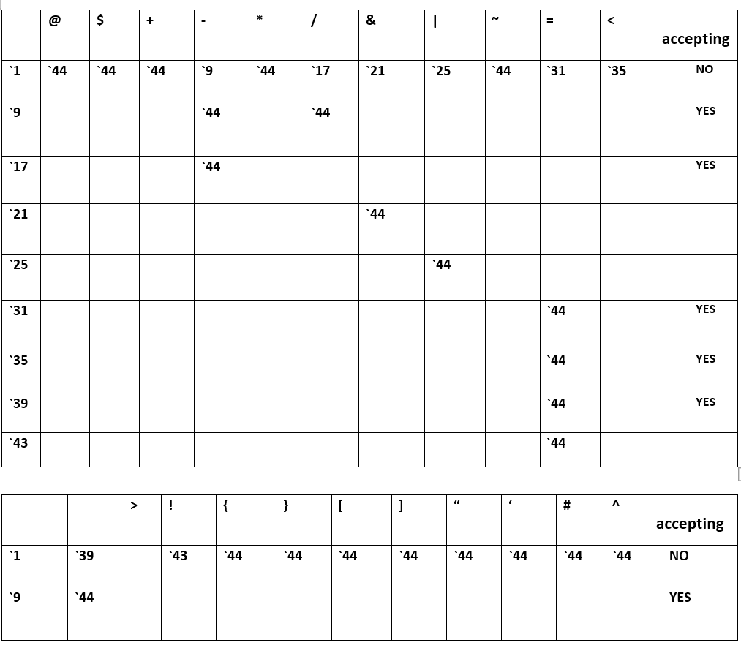

**###################################**

* The final NFA:

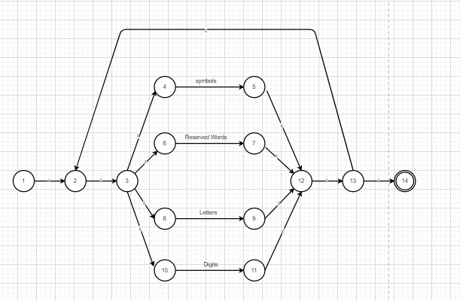

* The final DFA:

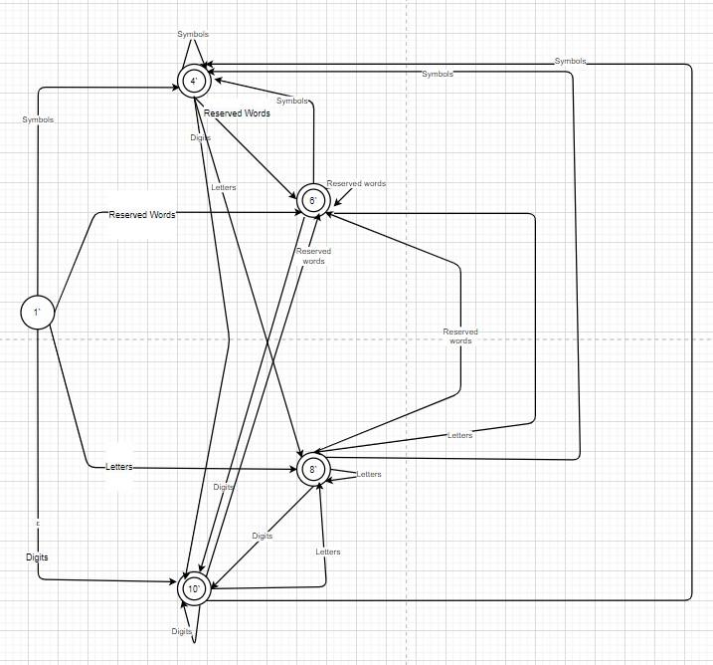

* The final transition table:

|  |  |  |  |  |  |
| --- | --- | --- | --- | --- | --- |
| State | Symbols | Reserved Words | Letters | Digits | Accepting |
| 1` | 4 | 6 | 8 | 10 | No |
| 4` | 4 | 6 | 8 | 10 | Yes |
| 6` | 4 | 6 | 8 | 10 | Yes |
| 8` | 4 | 6 | 8 | 10 | Yes |
| 10` | 4 | 6 | 8 | 10 | Yes |